TASK: Delete snapshots which is not in use to optimize the cost.

- Create EC2.
- Take snapshot of EC2
- 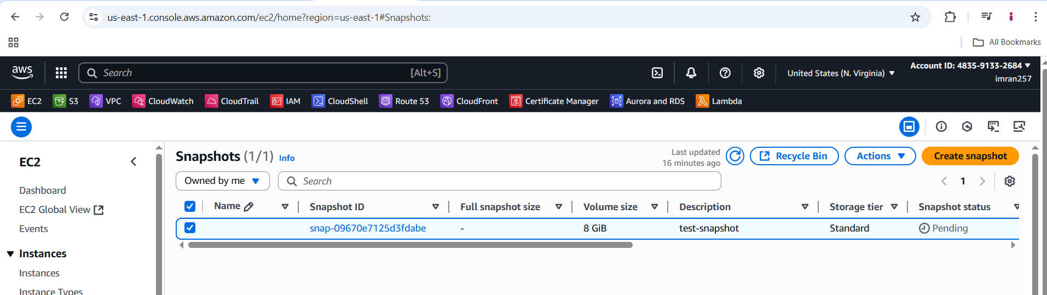
- Create a lambda function “cost-opt-ebs-snap”
- 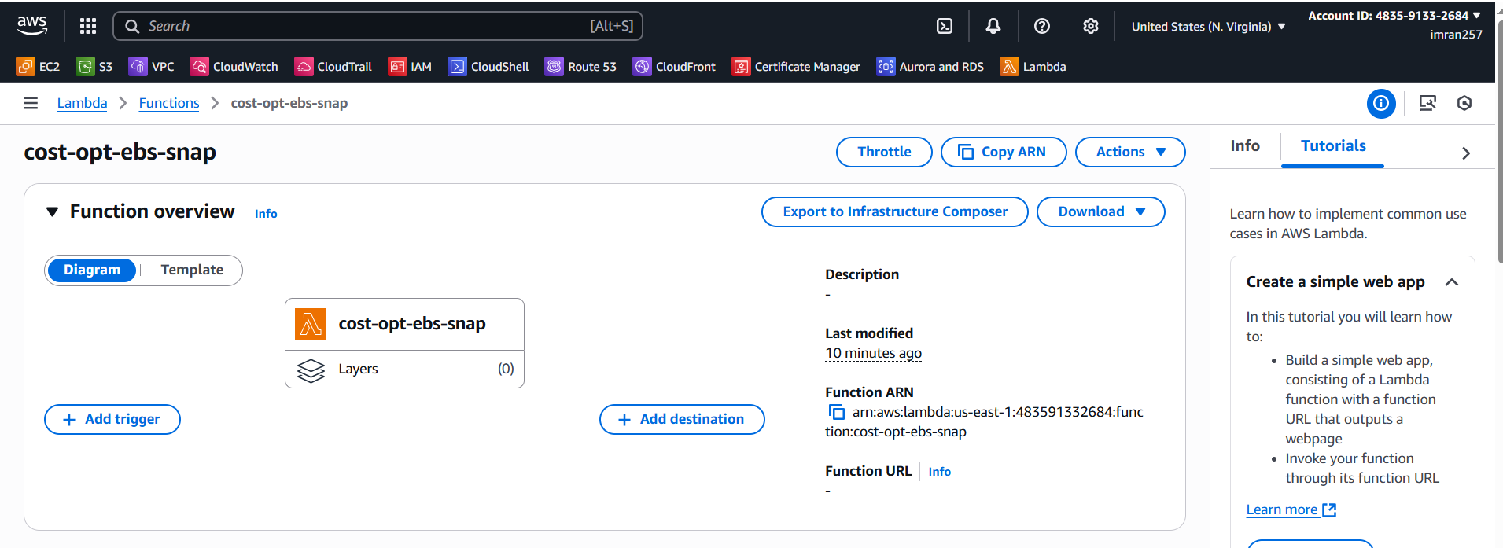
- Write the Code to list out snapshots and delete.
import boto3

def lambda_handler(event, context):
ec2 = boto3.client('ec2')

# Get all EBS snapshots
response = ec2.describe_snapshots(OwnerIds=['self'])

# Get all active EC2 instance IDs
instances_response = ec2.describe_instances(Filters=[{'Name': 'instance-state-name', 'Values': ['running']}])
active_instance_ids = set()

for reservation in instances_response['Reservations']:
for instance in reservation['Instances']:
active_instance_ids.add(instance['InstanceId'])

# Iterate through each snapshot and delete if it's not attached to any volume or the volume is not attached to a running instance
for snapshot in response['Snapshots']:
snapshot_id = snapshot['SnapshotId']
volume_id = snapshot.get('VolumeId')

if not volume_id:
# Delete the snapshot if it's not attached to any volume
ec2.delete_snapshot(SnapshotId=snapshot_id)
print(f"Deleted EBS snapshot {snapshot_id} as it was not attached to any volume.")
else:
# Check if the volume still exists
try:
volume_response = ec2.describe_volumes(VolumeIds=[volume_id])
if not volume_response['Volumes'][0]['Attachments']:
ec2.delete_snapshot(SnapshotId=snapshot_id)
print(f"Deleted EBS snapshot {snapshot_id} as it was taken from a volume not attached to any running instance.")
except ec2.exceptions.ClientError as e:
if e.response['Error']['Code'] == 'InvalidVolume.NotFound':
# The volume associated with the snapshot is not found (it might have been deleted)
ec2.delete_snapshot(SnapshotId=snapshot_id)
print(f"Deleted EBS snapshot {snapshot_id} as its associated volume was not found.")

- Create a policy with EC2 and select write permission for delete snapshot and select list describe snapshot, describe volume, describe instances.
- 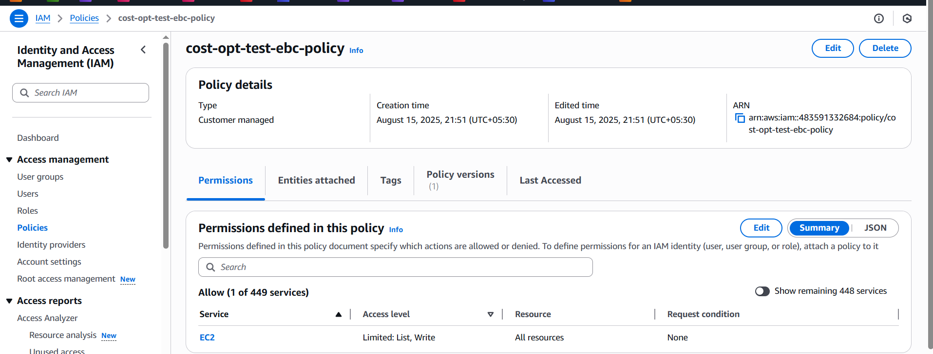
- Then your lambda function → configuration → Permissions → click the role and attach policy which you created.
- 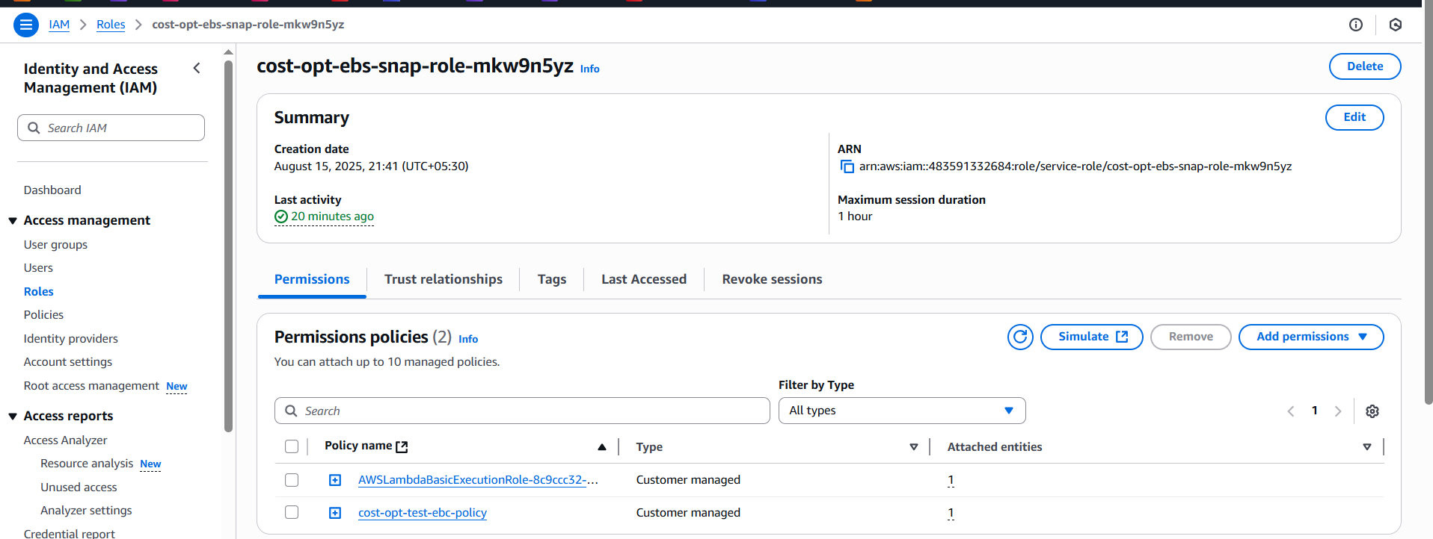
- Now lambda → code → test →
- 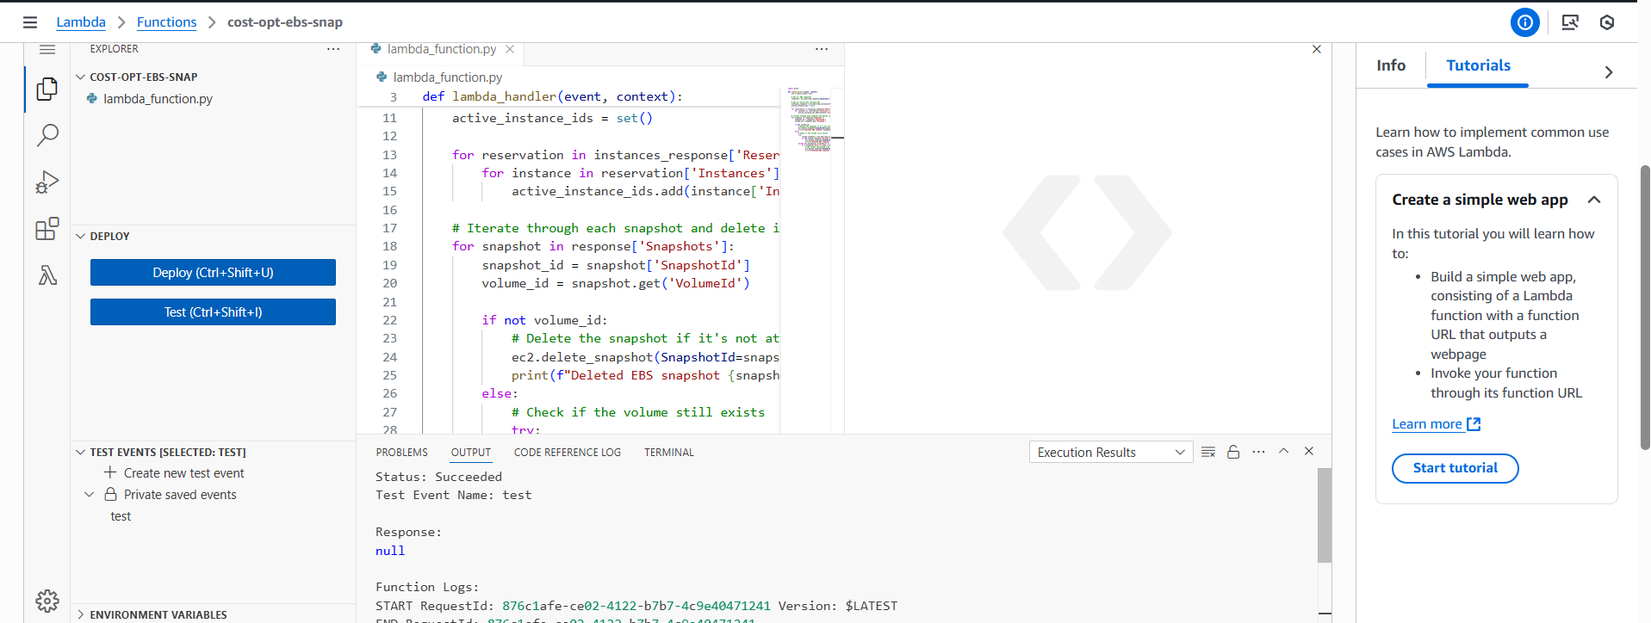
- The snapshot not deleted because its associated with EC2
- Now delete E2 so snapshot is available now , then lambda → code → test.
- 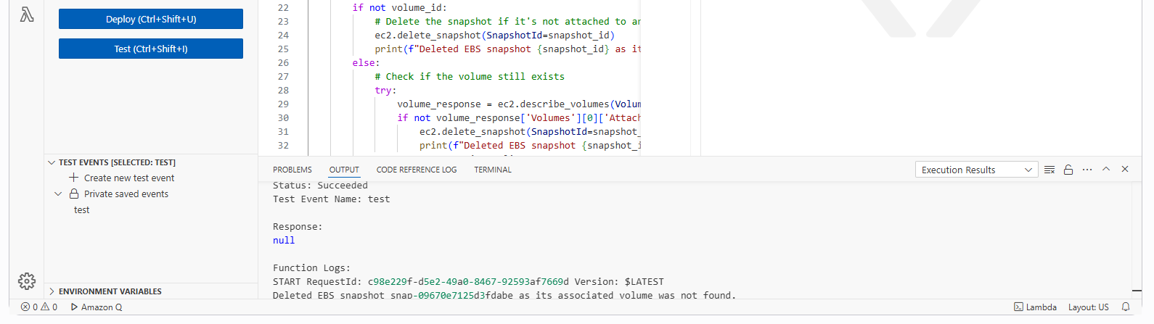
- Now the snapshot is deleted.
- 